**Dynamic Calculator: 1+2×3(4-5÷4) -(3÷5):**

Both the first and second methods are suitable for Jupiter Notebook.

The first method is also suitable for Python. In Jupiter we call it by using print ()

The second method is only suitable for Jupiter Notebook

**First Method:**

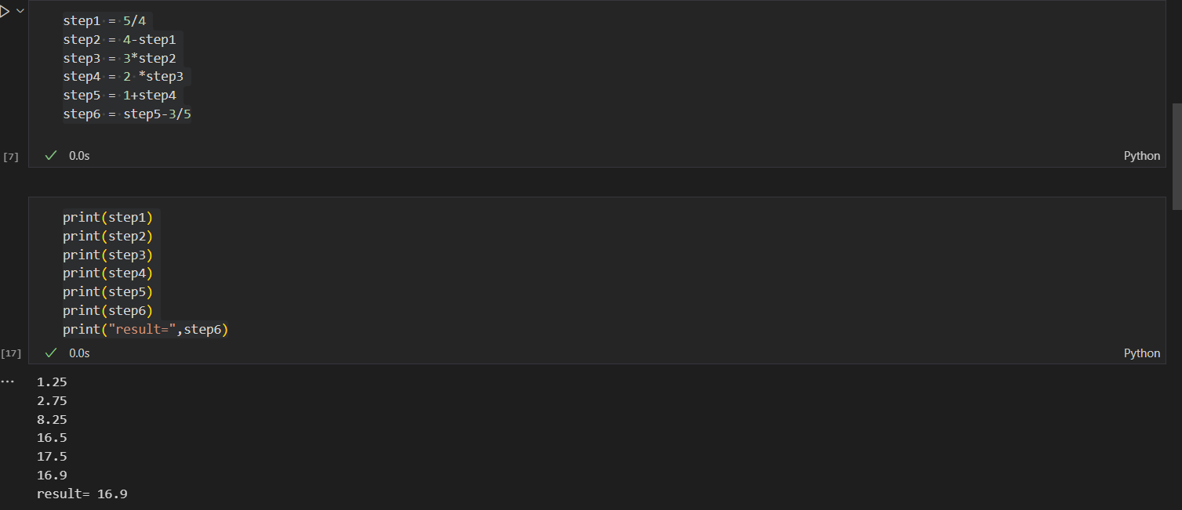

**DESCRIPTION OF First Method:**

**Why we use this?**

**debugging, or writing step-by-step calculations.**

**# Step 1:**

We solve the division inside the parentheses:

5÷4=1.25

So now the expression inside the brackets becomes:

4−1.25

**# Step2:**

4 - step1

4−1.25=2.75

This completes the part inside the parentheses.

**# Step3:**

 3 * step2

3×2.75=8.25

**#Step4:**

2 * step3

This completes:2×3(4−5/4)

**# Step5:**

1 + step4

1+16.5=17.5

Now we've completed:

1+2×3(4−5/4)

**# Step6:**

step5 - 3 / 5

= 16.9

**Second Method:**

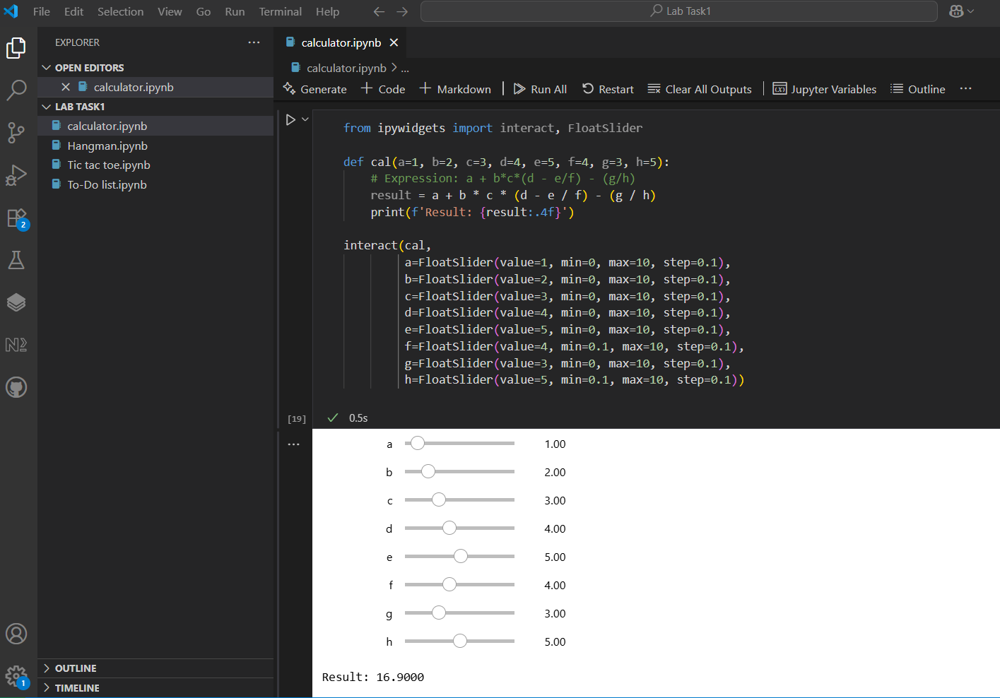

**Why we use this?**

suitable for interactive notebook environments.

• **interact**: a function that turns a regular function into an interactive widget. Automatically create sliders, layout etc.

    • **Float Slider:** a slider that allows decimal (float) values.

• This is designed for Jupiter Notebooks.

• Define a function with any name. write 8 parameters and give then value according to the question.

• Prints the result of the expression.

 • :.3f formats means after decimal it puts three zeros.

**Creates interactive sliders for each parameter:**

    • **value**: given in question

    • **min**: minimum allowed value (lowest value is 0)

    • **max**: maximum allowed value (100,500……)

    • **step**: how much the slider changes when moved (0.1 means fine slider)

**• a = 1 → Yeh expression first number**

(From 1 + ...)

**• b = 2 → 1st multiplier**

(From 2 × 3)

**• c = 3 → 2nd multiplier**

(From 2 × 3)

**• d = 4 → Bracket first number**

(From 4 - ...)

**• e = 5 → Bracket division numerator**

(From 5 ÷ 4)

**• f = 4 → Bracket division denominator**

(Min = 0.1 to avoid divide by zero)

**• g = 3 → Final subtraction numerator**

(From - (3 / 5))

**• h = 5 → Final division denominator**

(Min = 0.1 to avoid divide by zero)